ICSG PRESS RELEASE Date Issued: 22 July 2011

9
ICSG Directory of Global Copper First Use Capacity: 2011 Edition

The International Copper Study Group released its 2011 edition of the “Directory of Copper and Copper Alloy Fabricators – First Use”. This directory provides a systematic global overview of companies and plants involved in the “first use” of copper - the use of unwrought copper materials (refined copper, alloy ingots, direct melt scrap, etc.) as feed to the production of semi-fabricated products (copper wire rod; copper and copper alloy, sheet, strip, bar, rod, tube, etc.). The Directory covers wire-rod plants, brass mills, and electrodeposited copper foil mills. It also covers ingot makers, chemical plants and master alloy plants as suppliers to foundries and brass mills.
The 2011 edition of the Directory reports almost 43.7 million tonnes (Mt) gross weight capacity, including copper and copper alloy semi-fabrication and ingots castings plant. However, capacity is higher as we have identified plants currently operating that do not report capacity data. We found a significant expansion of wire rod capacity of over 1.34 Mt worldwide. We also improved the information coverage for many plants, with more plant addresses, emails, phones and websites now reported. In 2011 more than 20.9 Mt of wire rod capacity and close to 1.7 Mt of alloy wire capacity is operational worldwide. Plates, sheets and strips production capacity (PSS) is the second most reported worldwide by semis with almost 5.9 Mt in 2011; meanwhile rods, bars and sections (RBS) is the third most reported category with more than 5.28 Mt reported. Copper and copper alloy tube production capacity reported this year is close to 4.7 Mt. The reported production capacity of ingots as a first use of copper remains below 1.17 Mt, while the production capacity reported for copper foil products is approaching 470 Kt in 2011. Finally the reported first use capacity of copper powder remains below 64 Mt.

Based on the current Directory data we can obtain a broad look of the structure of the global copper first use industry. Over 47% of the reported capacity is concentrated in very large plants with capacity at or above 100 Kt, close to 33% of the capacity is represented by large plants (25 Kt to less than 100 Kt), around 13% of the global capacity is controlled by medium scale plants (10 Kt or less than 25 Kt) and the remaining 6% is controlled by smaller plants. As we observed in 2010 and confirmed with the updated database in 2011, the effective copper first use capacity must be higher than the data reported in the 2011 edition: 484 plants representing more than 23% of the plants identified, are not reporting any capacity information in 2011.
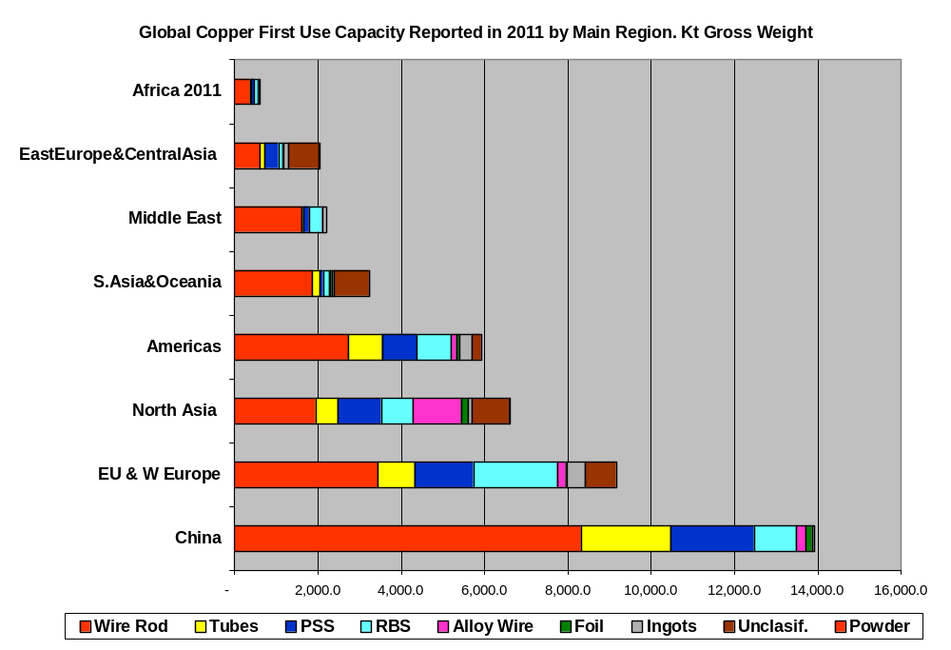
The Directory is available for sale to ICSG member country/non-member country clients at a price of €400/€600 respectively. An order form is attached to this press release.

International Copper Study Group Order Form
Prices are quoted in Euros. For US dollars payments contact ICSG (see below)

PUBLICATION | Member Country | Non-Member Country | Total
ICSG Directory of Copper & Copper Alloy Fabricators: 2011 Edition | €400 | €600 | ______€
- 20% discount for Copper Bulletin subscribers |  |  | -_____€
TOTAL ORDER |  |  | ______€

NOTE: ICSG members refer to orders originating from institutions based in ICSG member countries. ICSG member countries are: Australia, Belgium, Chile, China, Finland, France, Germany, Greece, India, Italy, Japan, Luxembourg, Mexico, Peru, Poland, Portugal, Russian Fed., Serbia, Spain, Sweden, and the U.S.

Name___________________________________________ Title ______________________________________

Company___________________________________________________________________________________

Address____________________________________________________________________________________

City _______________________ Postal Code_________________ Country___________________________

Tel ___________________ Fax__________________ E-mail______________________________________

Date _______________________________ Signed____________________________________________

METHOD OF PAYMENT
□ I enclose a cheque payable to the International Copper Study Group of _____________ Euros addressed to:
International Copper Study Group
R. Almirante Barroso, nº 38, 6th Floor
1000-013 Lisbon, Portugal

□ Please debit my VISA/Master Card for ________________ Euros

Card number

C.V.V. (Card Value Verification - last three digits of the number on the back of the card)

Cardholders Name _______________________________________ Expiry date ____________________

Signature ______________________________________________ Date: ________________________

Cardholders Address _______________________________________________________________________

US dollar payments and electronic bank transfers may be possible. Please contact the ICSG for details.
e-mail: mail@icsg.org tel: 351-21-351-3870 fax: 351-21-352-4035

